**ASSIGNMENT 12**

***Q1. Write a program to print first N terms of a Fibonacci series.***

*#include <stdio.h>*

*int main()*

*{*

*int i,n,t1=0,t2=1,t3;*

*scanf("%d",&n);*

*printf("%d %d ",t1,t2);*

*for(i=2;i<n;i++)*

*{*

*t3=t1+t2;*

*t1=t2;*

*t2=t3;*

*printf("%d ",t3);*

*}*

*return 0;*

*}*

***Q2. Write a program to calculate HCF of two numbers.***

*#include <stdio.h>*

*int main()*

*{*

*int i,n1,n2,hcf=1;*

*scanf("%d%d",&n1,&n2);*

*for(i=1;i<=n1 && i<=n2;i++)*

*{*

*if(n1%i==0 && n2%i==0)*

*{*

*hcf=i;*

*}*

*}*

*printf("%d",hcf);*

*return 0;*

*}*

***Q3. Write a program to display following patterns.***

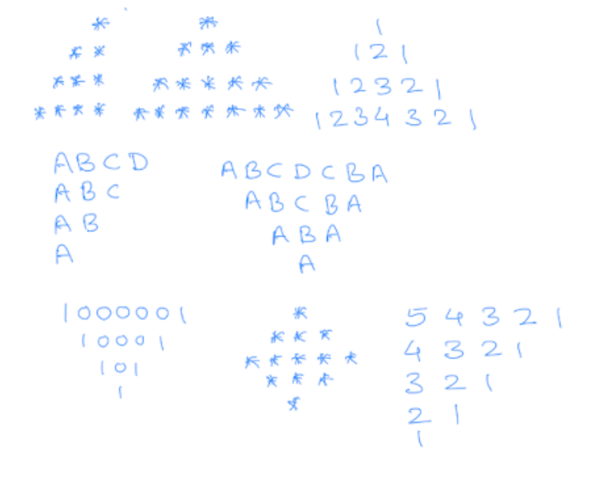



***(i).***

*#include <stdio.h>*

*int main()*

*{*

*int n,i,j;*

*scanf("%d",&n);*

*for(i=1;i<=n;i++)*

*{*

*for(j=1;j<=n;j++)*

*{*

*if(i+j>=n+1)*

*{*

*printf("*");*

*}*

*else*

*{*

*printf(" ");*

*}*

*}*

*printf("\n");*

*}*

*return 0;*

*}*

***(ii)***

*#include <stdio.h>*

*int main()*

*{*

*int n,i,j;*

*scanf("%d",&n);*

*for(i=1;i<=n;i++)*

*{*

*for(j=1;j<=n;j++)*

*{*

*if(i+j>=n+1)*

*{*

*printf("*");*

*}*

*else*

*{*

*printf(" ");*

*}*

*}*

*for(j=1;j<=n-1;j++)*

*{*

*if(i==1&&j==1)*

*{*

*printf(" ");*

*}*

*else if(i-1>=j)*

*{*

*printf("*");*

*}*

*}*

*printf("\n");*

*}*

*return 0;*

*}*

***(iii)***

*#include <stdio.h>*

*int main()*

*{*

*int n,i,j,k;*

*scanf("%d",&n);*

*for(i=1;i<=n;i++)*

*{*

*k=1;*

*for(j=1;j<=n;j++)*

*{*

*if(i+j>=n+1)*

*{*

*printf("%d",k++);*

*}*

*else*

*{*

*printf(" ");*

*}*

*}*

*for(j=1;j<=n-1;j++)*

*{*

*if(i==1&&j==1)*

*{*

*printf(" ");*

*}*

*else if(i-1>=j)*

*{*

*printf("%d",--k-1);*

*}*

*}*

*printf("\n");*

*}*

*return 0;*

*}*

***(iv)***

*#include <stdio.h>*

*int main()*

*{*

*int i,j,n;*

*scanf("%d",&n);*

*for(i=1;i<=n;i++)*

*{*

*char c='A';*

*for(j=1;j<=n;j++)*

*{*

*if(i+j<=n+1)*

*{*

*printf("%c",c++);*

*}*

*}*

*printf("\n");*

*}*

*return 0;*

*}*

***(v)***

*#include <stdio.h>*

*int main()*

*{*

*int i,j,n;*

*scanf("%d",&n);*

*for(i=1;i<=n;i++)*

*{*

*char c='A';*

*for(j=1;j<=n;j++)*

*{*

*if(i<=j)*

*{*

*printf("%c",c++);*

*}*

*else*

*{*

*printf(" ");*

*}*

*}*

*for(j=1;j<=n-1;j++)*

*{*

*if(i+j<=n)*

*{*

*printf("%c",--c-1);*

*}*

*}*

*printf("\n");*

*}*

*return 0;*

*}*

***(vi)***

*#include <stdio.h>*

*int main()*

*{*

*int i,j,n;*

*scanf("%d",&n);*

*for(i=1;i<=n;i++)*

*{*

*int k=1;*

*for(j=1;j<=n;j++)*

*{*

*if(i<=j)*

*{*

*if(i+j==2*i)*

*printf("%d",k);*

*else*

*printf("%d",k-1);*

*}*

*else*

*{*

*printf(" ");*

*}*

*}*

*for(j=1;j<=n-1;j++)*

*{*

*if(i+j<=n)*

*{*

*if(i+j==n)*

*printf("%d",k);*

*else*

*printf("%d",k-1);*

*}*

*}*

*printf("\n");*

*}*

*return 0;*

*}*

***(vii)***

*#include <stdio.h>*

*int main()*

*{*

*int i,j,n;*

*scanf("%d",&n);*

*for(i=1;i<=n;i++)*

*{*

*int k=1;*

*for(j=1;j<=n;j++)*

*{*

*if(i+j>=n+1)*

*printf("*");*

*else*

*printf(" ");*

*}*

*for(j=1;j<=n-1;j++)*

*{*

*if(i==1 && j==1)*

*printf(" ");*

*else if(i-1>=j)*

*printf("*");*

*}*

*printf("\n");*

*}*

*n=n-1;*

*for(i=1;i<=n;i++)*

*{*

*printf(" ");*

*for(j=1;j<=n;j++)*

*{*

*if(i<=j)*

*printf("*");*

*else*

*printf(" ");*

*}*

*for(j=1;j<=n;j++)*

*{*

*if(i+j<=n)*

*printf("*");*

*}*

*printf("\n");*

*}*

*return 0;*

*}*

***(viii)***

*#include <stdio.h>*

*int main()*

*{*

*int i,j,n,k;*

*scanf("%d",&n);*

*for(i=1;i<=n;i++)*

*{*

*k=n+1-i;*

*for(j=1;j<=n;j++)*

*{*

*if(i+j<=n+1)*

*{*

*printf("%d",k--);*

*}*

*}*

*printf("\n");*

*}*

*return 0;*

*}*